**Peer graded assignment: Coursera Capstone Project- The Battle of neighborhoods**

**(a part of IBM data Science professional certification course)**

**Introduction**

The City of New York is the biggest city of United States having estimated population more than 20 million in its metropolitan area. It is also the most visited tourist place in the world, famous for its history, diversified culture, museums, buildings architecture and cuisine too. Its food culture includes an array of international cuisines influenced by the city’s immigrant history.

Sushi restaurants have become so popular in the US now that its available at every corner even in the small cities. Starting a Sushi restaurant can be a great business opportunity, but one need to distinguish itself from others to enjoy long term success.

**Business Problem**

The purpose of this study is to help people who are planning to open a new restaurant in New York City Manhattan area, choosing the right location based on neighborhoods income and population and the competitors already present in the same regions. Manhattan has full potential but also is a very challenging district to open a business because of high competition and cost. New sushi bar should be open in an area that serves inadequate neighborhood in this way the bar can attract more customers. Therefore, this analysis necessary to ensure that we have enough customers and that we are not so close to other sushi places.

There are many aspects of making a business proposal for opening a restaurant, which includes study of populations, people’s income, competitors, their locations etc. but in this project study, we will be keeping ourselves limited to understanding competitors’ location in Manhattan neighborhood.

**Data**

To identify the characteristics of our competitors' venues in Manhattan, we would first need to find out the number of sushi bars in Manhattan currently and their location.

We then used Google Map API to find their geographic coordinates based on their postal code addresses.

In Manhattan, there is 1104 sushi bars are currently operating.

Getting NYC neighborhoods locational details from - <https://cocl.us/new_york_dataset>

Foursquare database: [https://Foursquare.com](https://foursquare.com/) to be used in order to explore the desired neighborhood data for various restaurant details in Manhattan area and access the JSON files. This data shall be utilized to map the Sushi restaurants at various locations.

**Methodology**

This section represents the main component of the report where the data was gathered and prepared for analysis. The tools described are used here and the Jupitor Notebook cells indicates the execution of steps.

We explored neighborhoods, segmented them and grouped them into clusters to find similar neighborhoods. To be able to do that, we needed to cluster data which is a form of unsupervised machine learning: k-means clustering algorithm. Thus, by applying K-means clustering approach, we completed this task. Folium library was used to visualize the neighborhoods in Manhattan and its emerging clusters. The tables and graphs generated in the process can be seen in Appendix-A and Jupitor notebook enclosed.

**Results**

Based on data frame analysis above, Cluster 3 (Upper West Side) is the best location to open a new sushi bar business.

**Discussion**

Looking at the tables and charts in the Jupitor notebook, we observed that there is high competition in Midtown and Soho, so it is very risky to open business in these areas. Central Harlem also has potential which is close to Morningside Heights area.

A more detailed analysis can be done by adding other factors such as transportation, demographics of inhabitants, their income etc.

**Conclusion**

Purpose of this study was to find out a suitable location for a new sushi bar which has been met. However, this problem can be taken up further with bigger scope and a lot more study can be carried out with other aspects before we narrowed down and finalized one location.

Appendix-A

NYC boroughs details:

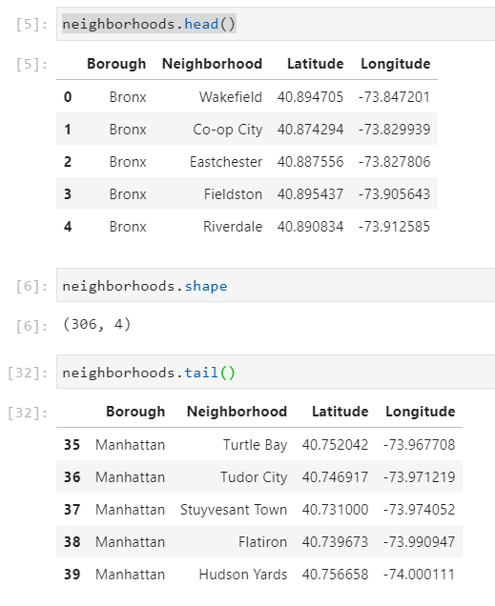

Manhattan neighborhoods map:

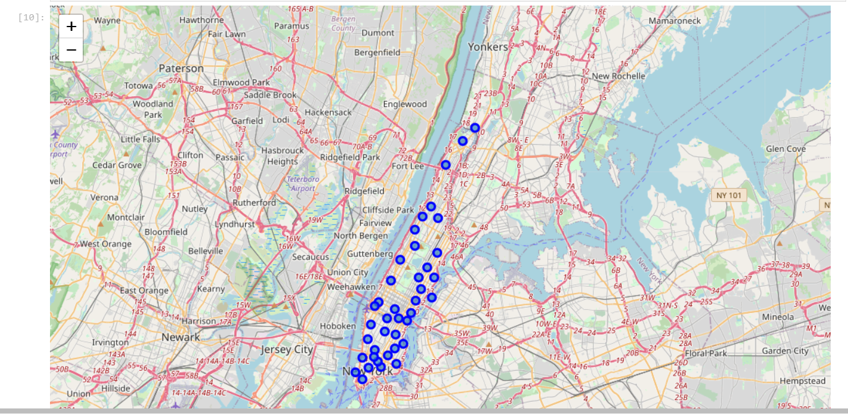

Sushi/Japanese Restaurants locations:

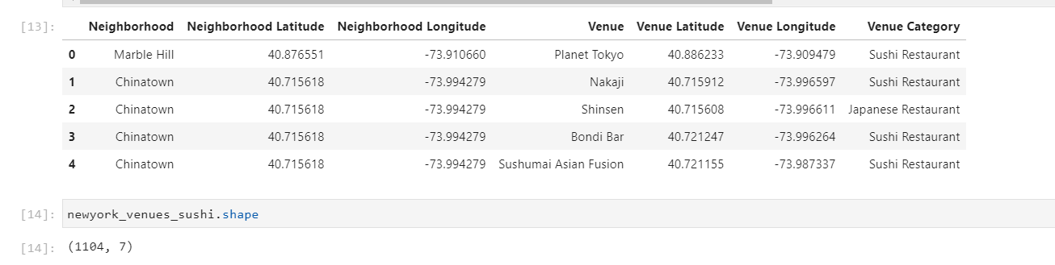

Manhattan neighborhoods clusters map:

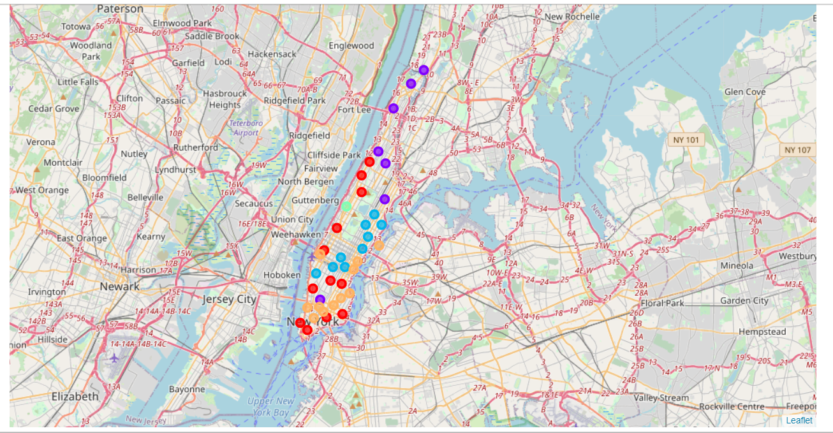

Applying K-mean clustering approach and finding best location:

